Submitted to: Vidya Narayan
Submitted by:
Kamalpreet Kaur
Rajvir Aujla
NOTEBOOK ON PALM ISLAND
INFO20172
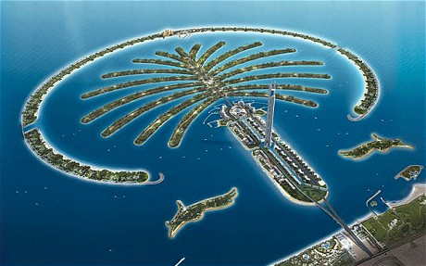
Table of content:

Introduction …………………………………………………………………………………………………………………………….
Palm Jumeira…………………………………………………………………………………………………………………………..
How to reach…………………………………………………………………………………………………………………………….
Design analysis……………………………………………………………………………………………………………………….
Construction ……………………………………………………………………………………………………………………………
SWOT analysis………………………………………………………………………………………………………………………….
Quality Management………………………………………………………………………………………………………………
Risks and threats…………………………………………………………………………………………………………………….
Effect on environment……………………………………………………………………………………………………………
Overview……………………………………………………………………………………………………………………………………......
References……………………………………………………………………………………………………………………………………

Introduction:

Palm island is composed of three islands: Palm Jumeirah, Palm Jebel Ali, Palm Deira.It is located in Dubai, Untied, and Arab Emirates. It is in the shape of palm tree. Its’ Concept design is by Helman Hurley and Charvat Peacock. It was handed over to nakheel properties.
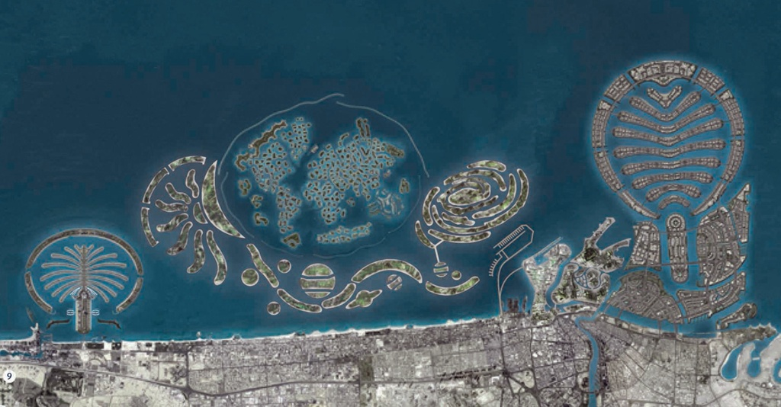

Palm Jumeirah:

Palm jumeirah is one of the three planned islands which would have extended into the Persian Gulf by a total of 520 kilometres. It is the smallest of all three.

Transportation: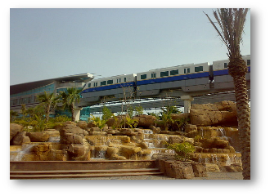

There is railing facility called mono Railing. Monorail uses Hitachi Monorail straddle-type technology. It is Opened on 30 April 2009.There are 4 stations of monorail

Planning:

It was a four year project plan. It is designed to develop tourism in Dubai .Building a city at sea (covered with luxury villas, apartments, towns and homes, entertainment areas, shopping malls, restaurants etc.)

Construction:

Construction process was started in the August of 2001.It was constructed through process of land reclamation .Construction was started with the scientific studies and surveys. First of all, construction of 11.5km long breakwater was started. Total of 40,000 of the workers were hired from the Asia and different parts of the country. There were two shifts of 12 hours. So, it was being built 24 hours.
The breakwater consists of three layers:
- Initial layer: of sand built up 7.5km from the sea floor.
- Second layer: rock that reaches 3m above the sea level.
- Final level: Armor stone on top, 6 tons each .
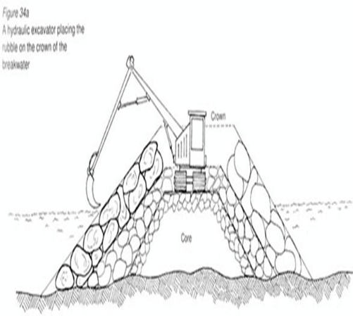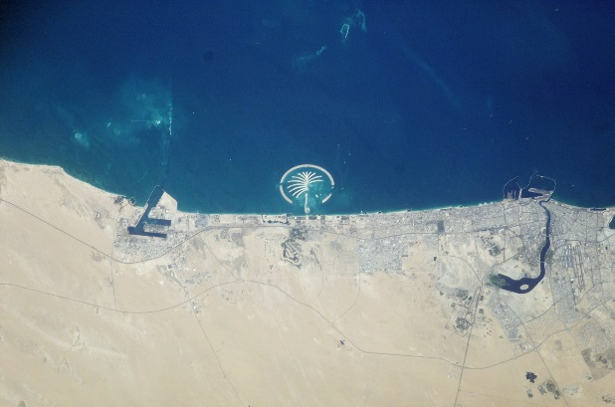
Breakwater was used to manage the earthquakes. To get the complex shape just right, designers and contractors use GPS to plot the palm. Palm Island is the best example of today’s technology.

SWOT ANALYSIS:
  - Strength:
- Palm Island has increased the number of tourists.
- It has also solved the land reclamation problem.
  - Weaknesses:
- Erosion of Sand that is caused by winds and water.
- Loss of coastal shape along the sea shore.
  - Opportunities:
- It has also increased the revenue of the country.
- Meets the requirement of the growing tourism
  - Threats:
- High waves.
- More storm frequency.
- More earthquakes.

SCOPE:

Because of the less geographic area and increasing no of visitors, they decided to build Palm Island. It attracts more than million tourists every year. This idea proves itself as a major revenue turning source for the country.

COST:

Its Estimated cost was around 2 billion USD (1.5 billion USD) but the final cost reached was 12.3 USD .The cost was managed by overcoming all the revenue weaknesses of Dubai.

TIME:

Its completion date was expected to be end of 2005 but it is delayed by 2 years
  - Reasons of Delay
- Erosion
- Due to the shape of the island right outside the coast of Dubai, there is loss of coastal shape along the seashore of Dubai

QUALITY MANAGEMENT:
Quality was managed by putting more of armor and rocks to make the sand harder and to prevent it from storms. Breakwater was used to manage the earthquakes. Day by Day palm island is improved by changing technology.

Risks and threatens:

Every project has some risks and threats involved in it. Palm Island also had some risks which are listed below. Storm frequency of 1 in 100 years.It’sWaves are 2 meter high.Earthquakes from 6 to 7 on the Richter scale. (Gulf area between Dubai and Iran is prone to earthquakes.).Weak soil due to constant exposure to rising sea water. Due to crisis the foreign investors stopped to invest.

EFFECT ON ENVIRONMENT:

It effects area's marine environment. Rocks and sand damaged oyster beds and coral reefs. Meanwhile, the owners of once-desirable shore properties complain that the islands have destroyed their view.

- What did your team produce?
Ans: My team did a great job for project on Palm Island. We studied and analyzed project management.
- Was the project a success or not? Include some type of quote or evaluation from the project sponsor.
Ans: No, the project as not success at all because time and cost both reaches much more higher than expected.
- What project management tools/documents did you use, and did they help?
Ans: Microsoft Project Manager. Yes it helped us a lot. We did most of the work with this.
- What project management tools/ documents were used on the initial project?
ANS: N/A
- What went right on the project?
Ans: It gets finished on time. We did our work on time and helped each other.
- What went wrong?
Ans: At one point, we got stuck with our research and we were not getting the directions but later on we solved our problem.
- What did your team learn by working on this project?
Ans: we learn how to work in a group and a lot about project management.
- How did you select the project manager? Did he/she do a good job at leading your team?
Ans: The project manager's role in a nutshell, is the overall responsibility for the successful planning, execution, monitoring, control and closure of a project. He had all the qualities of being a leader. Yes I am satisfied with my leader.
- Did you work well as a team?
Yes my team work well as team. All did their part with full concentration and we communicate well with each other and finished our work on time.
- How closely did you follow your plan? Discuss this information in your final project presentation.
Ans: We did everything as it was planned. We communicated well and as we were only two so there was no big problem.

